 

Systems & Biomedical Engineering Department Faculty of Engineering

Cairo University



Embedded 1st Project

0-99 Counter using Push Button

Gehad Mohamed Ahmed Ali Mohamed |Sec: 1|B.N: 28

# **Circuit Diagram:**

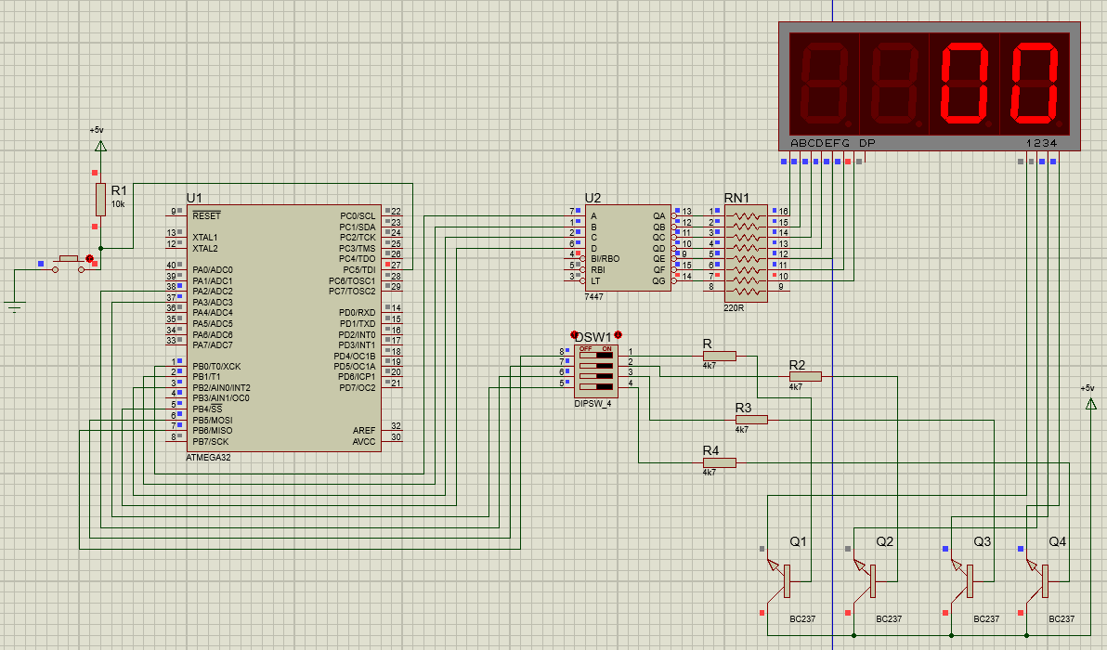

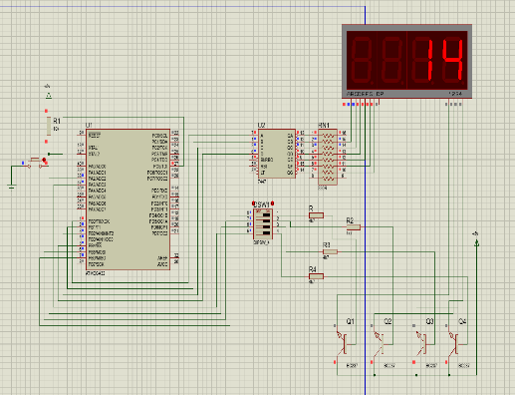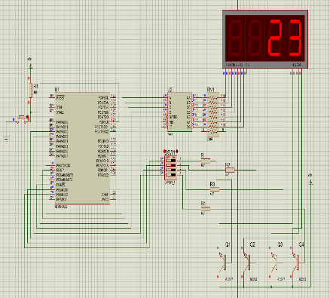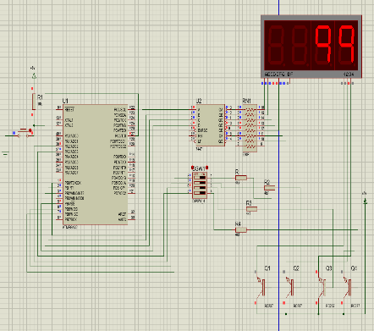

# Code:

